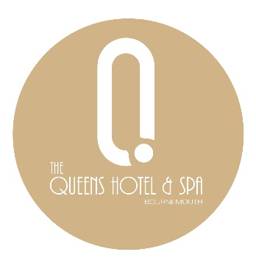

Mother’s Day Menu

Starters
Leek & Potato Soup, Crispy Leeks (VE)
Prawn & Crevette Cocktail, Marie Rose Sauce (GF)
Chicken Liver Parfait, Caramelised Onion Jelly, Crostini
Balsamic Beetroot, Whipped Vegan Feta, Candied Pecan (VE) (GF)

Mains
Roast Striploin (GF) or Roast Chicken Supreme (GF) or Beetroot Wellington (VE)
Roasted Potato, Carrots, Parsnips, Yorkshire Pudding,
Or
Herb Crusted Cod, Beurre Blanc
Creamy Mash, Crushed Peas,
Or
Sweet Potato & Chickpea Curry With Coconut Rice (VE)

Dessert
Sticky Toffee Pudding & Salted Caramel Ice Cream
Vanilla Cheesecake, Berry Compote, Meringues
Caramelised Apple Tart, Cider-Steeped Raisins, Clotted Cream Ice Cream
Chocolate & Raspberry Mousse, Sherbet (VE) (GF)

(V) Vegetarian (VE) Vegan (GF) Gluten Free
Please Let Us Know Of Any Allergens Before You Order. We Have Kitchen Protocols In Place To Address The Risk Of Allergen Cross-Contamination, However We Cannot Guarantee Their Total Absence In Our Dishes

